Our Ref: _______________ Your Ref: ________________________ Date: __________________

Baptist Church

Baale Yaku Site Area, P. O. Box 644,

Ogbomoso, Oyo State. Tel. 07052425407

Email: [newsprinbaptistchurch@gmail.com](mailto:newsprinbaptistchurch@gmail.com)

Website: newspringbc.comze.com

NEW SPRING

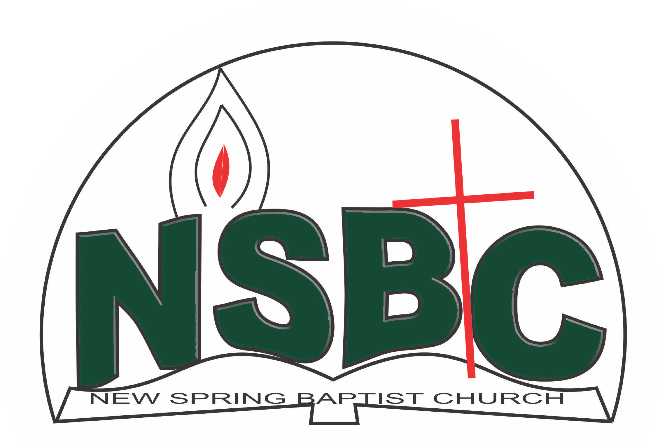

2 January 2022

Dear Mr. Johnson Olaniran,

Nomination to Serve as a Worker in the Church in 2022.

Calvary greetings in the precious name of our Lord and Saviour Jesus Christ. It is our pleasure to inform you that at the Church-in-Conference held on December 19, 2021; the Church ratified your nomination to serve in the following areas between January 1 and December 31, 2022.

1. Ex-Officio,Youth Fellowship
2. Member, Beautification & Decoration Committee under the Chairmanship of Mr. Akin Ogunlowo
3. Member, Church Property and Maintenance Committee under the chairmanship of Mr. Rotimi Adeniyi
4. Member, Health Committee under the chairmanship of Mrs. Nia Olupona
5. Member, Hospitality Committee under the chairmanship of Mrs. Mobolape Adelakun
6. Chairman, Membership Committee
7. Assistant Church Secretary and
8. Member, Church Council

Please refer to the table below for the key functions of each of these roles. Details can be found in the Church constitution. You are strongly encouraged to become familiar with the tasks as stated in the document. There will be an orientation of the Church workers on January 22, 2022 at 8:30 a.m. on the church premises. Please ensure you participate in this training.

“Now it is required that those who have been given a trust must prove faithful. I Corinthians 4:2”. May God find you faithful in the task He has assigned to you.

| Domain | Key function of Office, Department or Committee |
| --- | --- |
| Ex-Officio, Youth | To provide support to the Church Pastor in equipping the youth of the Church for Christ-like life style and responsible adulthood |
| Church Property / Maintenance Committee | The committee is responsible for managing all Church fixed and non-fixed properties. |
| Beautification & Decoration Committee | Responsible for the ornamentation of the Church building and premises |
| Health Committee | Support the Church Pastor in providing professional guidance to the Church in health related matters of the Church members |
| Hospitality Committee | The committee is responsible for organizing social activities of the Church |
| Membership Committee | The committee is responsible for the overall management of the membership of the Church. |
| Asst. Church Secretary | To assist the secretary and carry out other duties assigned |
| Church Council member | The Church Council is the governing body of the Church whose membership, under the leadership of the Holy Spirit, holds one another mutually accountable with respect and love and sees to the smooth running of the Church. |
|  |  |

Thank you for accepting to serve in this Church.

Yours in His service

Olusayo Okediji Blessed Agboola

Church Secretary                                                                                     Chairman, Nominating Committee